Data Communication and Net-Centric Computing
Group Assignment 2
Group 33
Nikolas Papakalodoukas (s4094240) | Alexandre Lee (s4090276)
Thomas Gosling (s3850201) | Jayden Bolth (s4104354)
# | Requirement | Status | Double Checked / Verified
1 | Student names and IDs included | ✅
2 | Student ID appended in every device name in Packet Tracer screenshots | ❌
3 | Task A1: Two subnet designs with intuition (5 marks) | ✅
4 | Task A1: Design comparison with advantages/disadvantages (2 marks) | ✅
5 | Task A1: mod 2 student ID → last 8 bits → IP address (2 marks) | ✅
6 | Task A2: Network configuration with all devices (3 marks) | ✅
7 | Task A2: Sales server web app via TCP (3 marks) | ✅
8 | Task A2: IT server UDP real-time service (3 marks) | ✅
9 | Task A2: DNS query with domain name (2 marks) | ✅
10 | Task A2: DNS packet monitoring at L2/L3/L4 (2 marks) | ✅
11 | Task A2: Design choices explanation ≤250 words (2 marks) | ✅
12 | Task B.1: FCS explanation with 3-5 steps and diagram (3 marks) | ✅
13 | Task B.2: TCP/IP layer for FCS + integrity explanation (3 marks) | ✅
14 | Task B.3: TCP vs UDP trade-off example (2 marks) | ✅
15 | Task C: Clear structure, presentation, referencing (3 marks) | ✅
16 | Group member contributions table included | ❌

Task A
Car Sales Melbourne City has recently relocated from Richmond. The company consists of four main departments: Marketing, Administration, IT, and Sales. Currently, each of Marketing, Administration and Sales departments has 40 staff, while the fast-growing IT department has 60 staff. Assume that the company has been assigned the IP address 192.100.30.0. As a networking engineer at Car Sales Melbourne City, your task is to design and implement a new private network for the company.

Task A1: Designing Potential Subnets 1, 2, 3 and 4

1. Subnet Designs (9 marks)
Departmental requirements:
Departments | Marketing | Administration | Sales | IT
Requirements | 40 | 40 | 40 | 60 + fast growing

Subnet Design 1
Design 1 utilises a FSLM approach, subdividing the network into 4 subnets of equal size, using 26 bits for the network address and giving each subnetwork a total of 62 hosts each.
Since each department is provisioned with only 2 PCs by default, it is highly probable that Car Sales Melbourne City accommodates a BYOD (Bring Your Own Device) work environment, suggesting that staff will require IP addresses for multiple devices (e.g., laptop and smartphone). Because of this, Design 1 doesn’t have adequate support for multiple devices per person in a BYOD workplace, nor for extra capacity, especially for the IT department
Subnet | Network Address | Usable IP Range | Broadcast Address | CIDR
IT – Subnet 1 | 192.100.30.0 | 192.100.30.1 – 192.100.30.62 | 192.100.30.63 | /26
Marketing – Subnet 2 | 192.100.30.64 | 192.100.30.65 – 192.100.30.126 | 192.100.30.127 | /26
Administration – Subnet 3 | 192.100.30.128 | 192.100.30.129 – 192.100.30.190 | 192.100.30.191 | /26
Sales – Subnet 4 | 192.100.30.192 | 192.100.30.193 – 192.100.30.254 | 192.100.30.255 | /26

Subnet Design 2: Supernet Configuration
The IP address assigned to Car Sales Melbourne City, 192.100.30.0, is a public Class C address belonging to RIPE NCC (Réseaux IP Européens Network Coordination Centre). By default, a Class C address implies a /24 subnet mask, providing 255 total addresses (254 usable). However, given the staffing requirements across all four departments, a total of 180 staff require network access — approximately 70% utilisation of the 255 available addresses if one device per person is assumed.
Furthermore, RIPE NCC stipulates that 80% of a reasonable allocation must be utilised before additional allocations can be granted (RIPE NCC, 2026a). The aforementioned BYOD environment justifies the 80% minimum requirement for additional allocation, as the actual address demand per person is likely to exceed one device.
Given these considerations, a /23 supernet (512 addresses) is necessary. However, even 512 addresses may not be sufficient to accommodate at least 2 devices per person (computer and phone) across all departments simultaneously. Therefore, additional measures such as IP address recycling will need to be employed to manage the address space efficiently.
To accommodate this, permission from the ISP to supernet must be requested. RIPE NCC policy requires that at least 50% of the current allocation must be utilised within one year, otherwise the allocation may be downgraded (RIPE NCC, 2026b). Assuming two devices per person, the 70% utilisation threshold is comfortably exceeded, justifying the need for additional address space.
Department | Staff (Needed) | Allocated IPs | CIDR | Network Address | Usable Range | Broadcast Address
IT | 60 | 126 | /25 | 192.100.30.0 | 192.100.30.1 to .126 | 192.100.30.127
Marketing | 40 | 62 | /26 | 192.100.30.128 | 192.100.30.129 to .190 | 192.100.30.191
Admin | 40 | 62 | /26 | 192.100.30.192 | 192.100.30.193 to .254 | 192.100.30.255
Sales | 40 | 62 | /26 | 192.100.31.0 | 192.100.31.1 to .62 | 192.100.31.63

This configuration allocates a /25 (126 usable addresses) to the fast-growing IT department, providing ample room for expansion, while each of the remaining three departments receives a /26 (62 usable addresses). The supernet spans from 192.100.30.0/23 to 192.100.31.255/23, effectively aggregating the four subnets under a single supernet prefix.

2. Subnet Design Comparison: Advantages and Disadvantages
Design # | Advantages | Disadvantages
Subnet Design 1 | Allows even growth (of about 22 users) for each department | Lacks capacity for future organisational growth, especially for IT (fast growing but only 2 slots fee)
Subnet Design 2 (Supernet) | IT department receives /25 (126 addresses), 66 spare slots; Other departments each receive /26 (62 addresses), 22 spare slots each; the /23 supernet provides decent headroom for BYOD capability, supporting at least 2 devices per person | Requires ISP permission to supernet beyond the default /24; even 512 addresses may not be sufficient if every staff member uses more than 2 devices simultaneously

In my opinion, Subnet Design 2 (Supernet) is the superior choice. Design 1 is fundamentally flawed for this organisation as it allocates only 62 addresses per subnet, leaving insufficient spare addresses for all departments, especially for IT, and inadequate for BYOD work environment, as additional devices will exhaust the IT subnet and severely strain the others department’s subnets.
In contrast, Design 2's supernet accounts for the growth expectation of each department, and leverages a /23 block (512 addresses) for the IT department, obtained through ISP permission, justified by the 70% utilisation of the original /24 and the BYOD-driven demand for multiple devices per person. This configuration maximises departmental growth and comfortably supports at least 2 devices per staff member, and aligns with RIPE NCC's 50% minimum utilisation policy (RIPE NCC, 2026b).

3. Deciding the IP Address from Mod 2 Operation of Nikolas' Student ID
Goal: Nikolas' student ID: s4094240, converted to 4094240, then mod 2
Mathematical Working Out | IP address: 192.100.30.32
4094240 mod 2 = 0, quotient: 2047120  2047120 mod 2 = 0, quotient: 1023560  1023560 mod 2 = 0, quotient: 511780  511780 mod 2 = 0, quotient: 255890  255890 mod 2 = 0, quotient: 127945  127945 mod 2 = 1, quotient: 63972  63972 mod 2 = 0, quotient: 31986  31986 mod 2 = 0, quotient: 15993  The first bit found is the least significant bit.  First 8 bits (LSB first): 0 0 1 0 0 0 0 0 = 32 | 192.100.30.32 falls within the IT department subnet (192.100.30.0/25), which has usable hosts ranging from 192.100.30.1 to 192.100.30.126, and a broadcast address of 192.100.30.127.

Task A2: Implement Subnet Design Using Packet Tracer v8.2.2

1. Network Configuration
The network [Figure 1] uses a router, core switch, and separate departmental switches for Marketing, Admin, Sales, and IT. VLSM subnetting and VLANs [Figure 2] were used to allocate addresses efficiently, separate departments into broadcast domains, reduce unnecessary traffic, and support inter-VLAN communication through router-on-a-stick and trunk links [Figure 3].
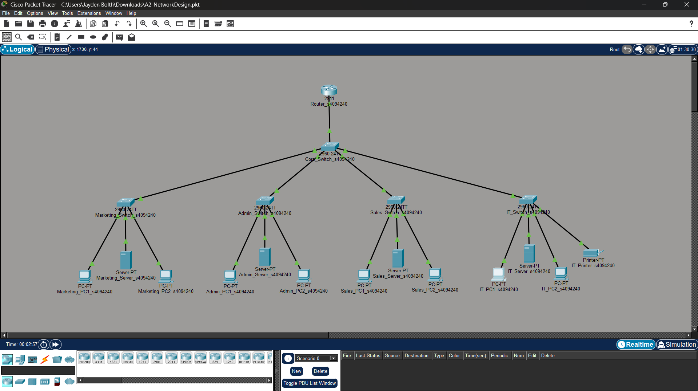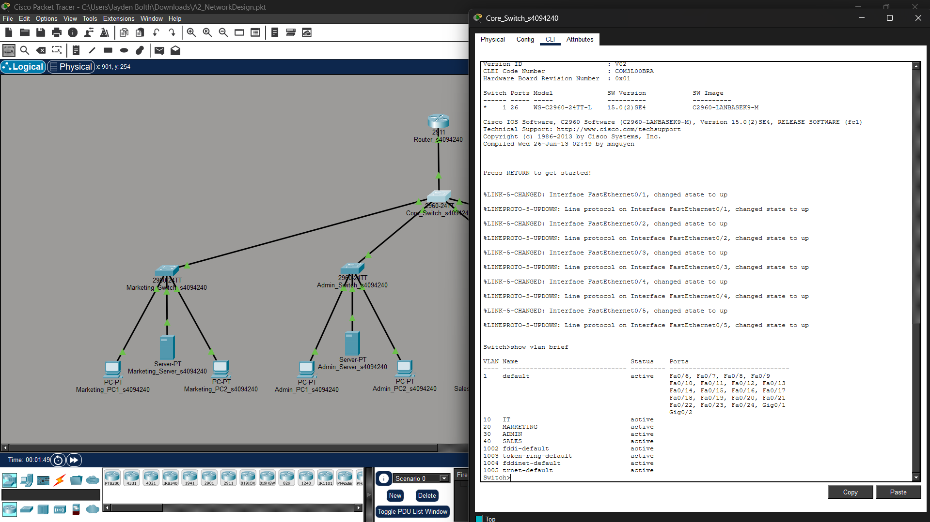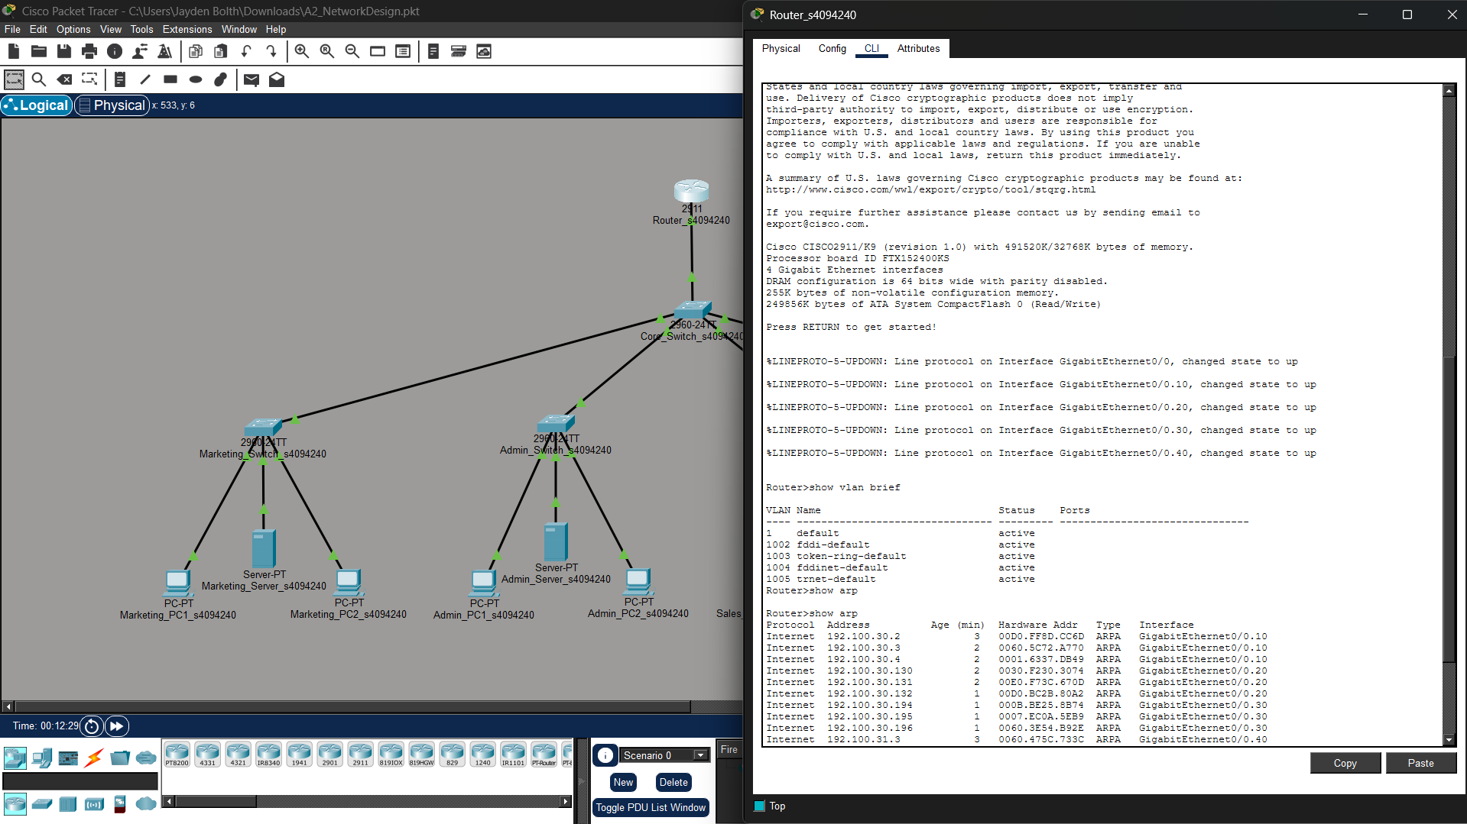
Figure 1[left most]: Network Architecture / Figure 2[middle image]: VLAN Segmentation Configuration / Figure 3[right most]: VLAN Demonstration

2. Application Service Configuration; Sales and IT Server Web Applications:
The Sales server [Figure 4 / 5] hosts an HTML web application using HTTP over TCP. Accessing 192.100.31.2 from another department confirmed that the service is reachable across VLANs through inter-VLAN routing.
The IT server [Figure 6] was configured as the destination for periodic UDP traffic, simulating a real-time streaming service across the VLAN network. Simulation Mode confirmed continuous UDP communication at Layer 4, using source port 50000 and destination port 53.
The UDP simulation [Figure 7] was verified in the Simulation Mode by monitoring packets arriving at the IT department server. The OSI Model view confirms UDP communication at Layer 4 using source port 50000 and destination port 53, while Layer 3 displays the source and destination IP addresses.
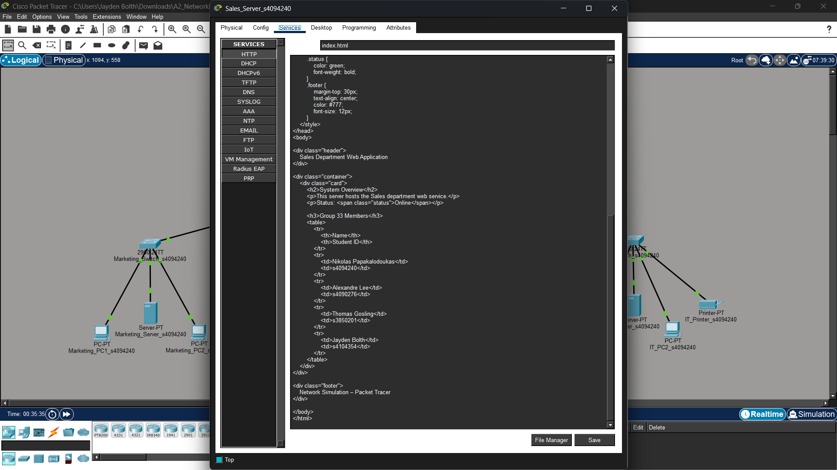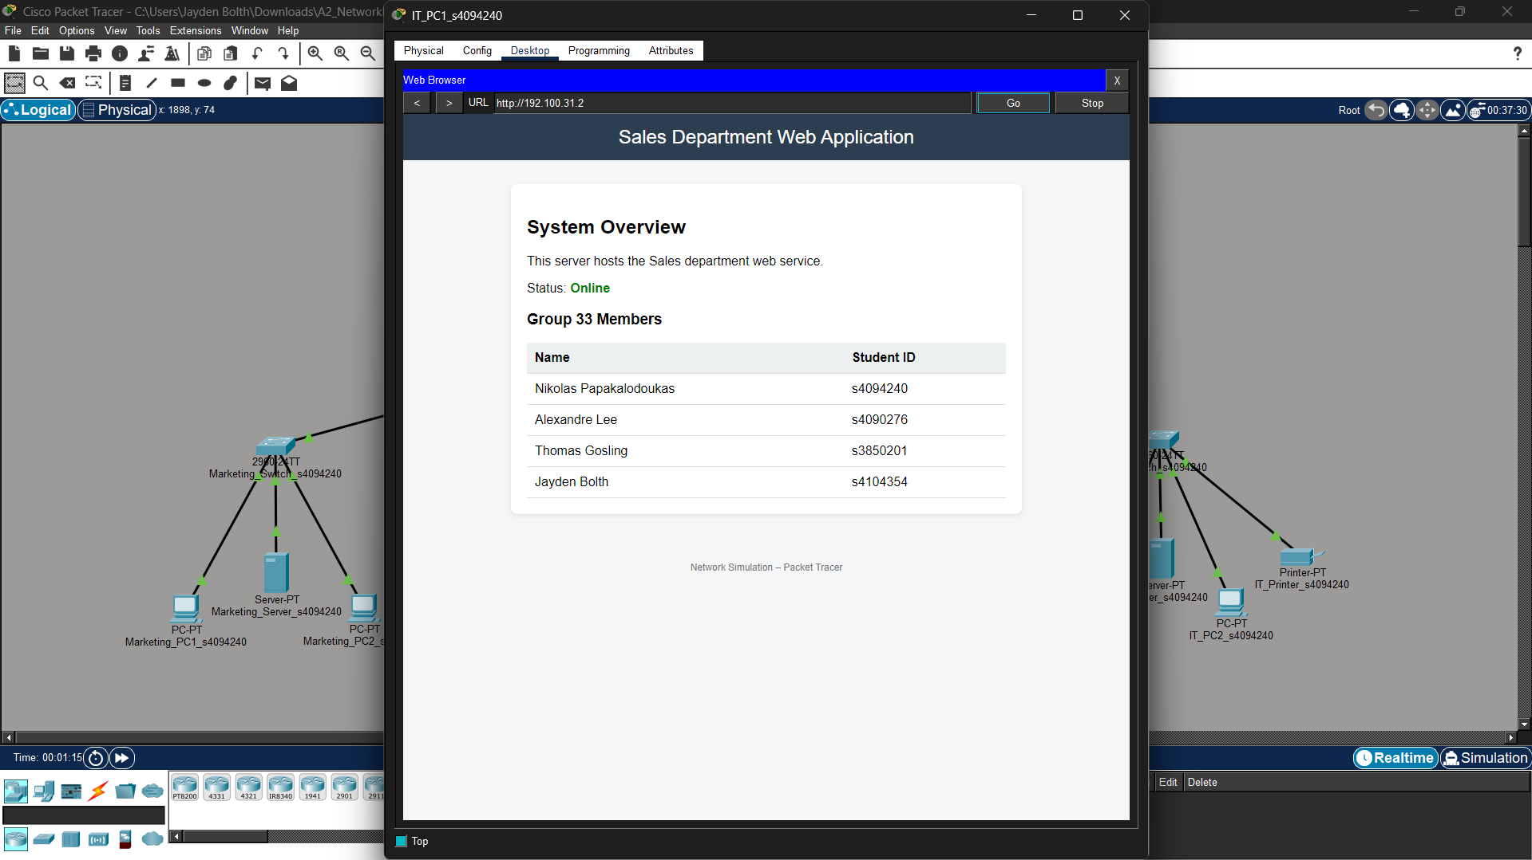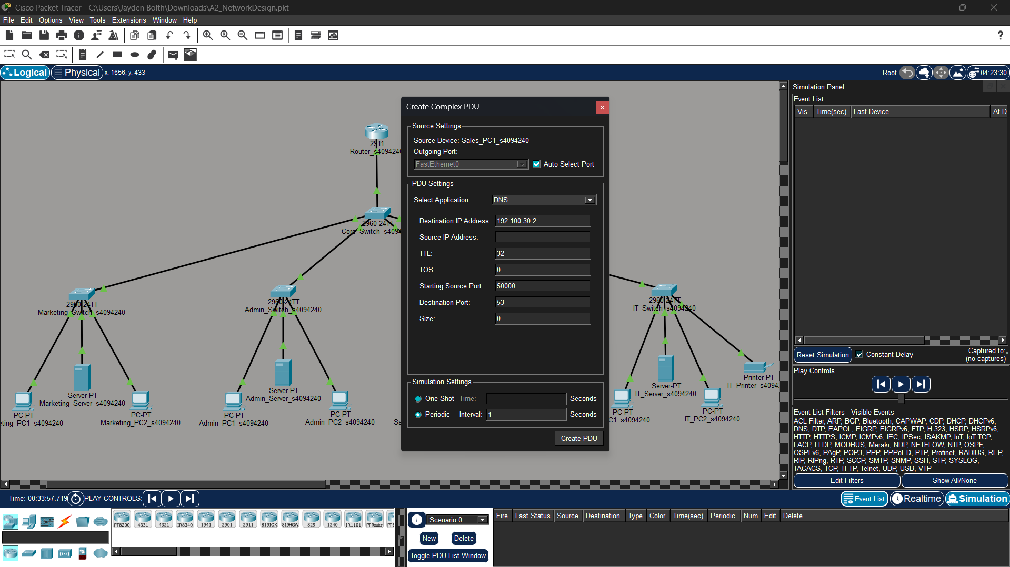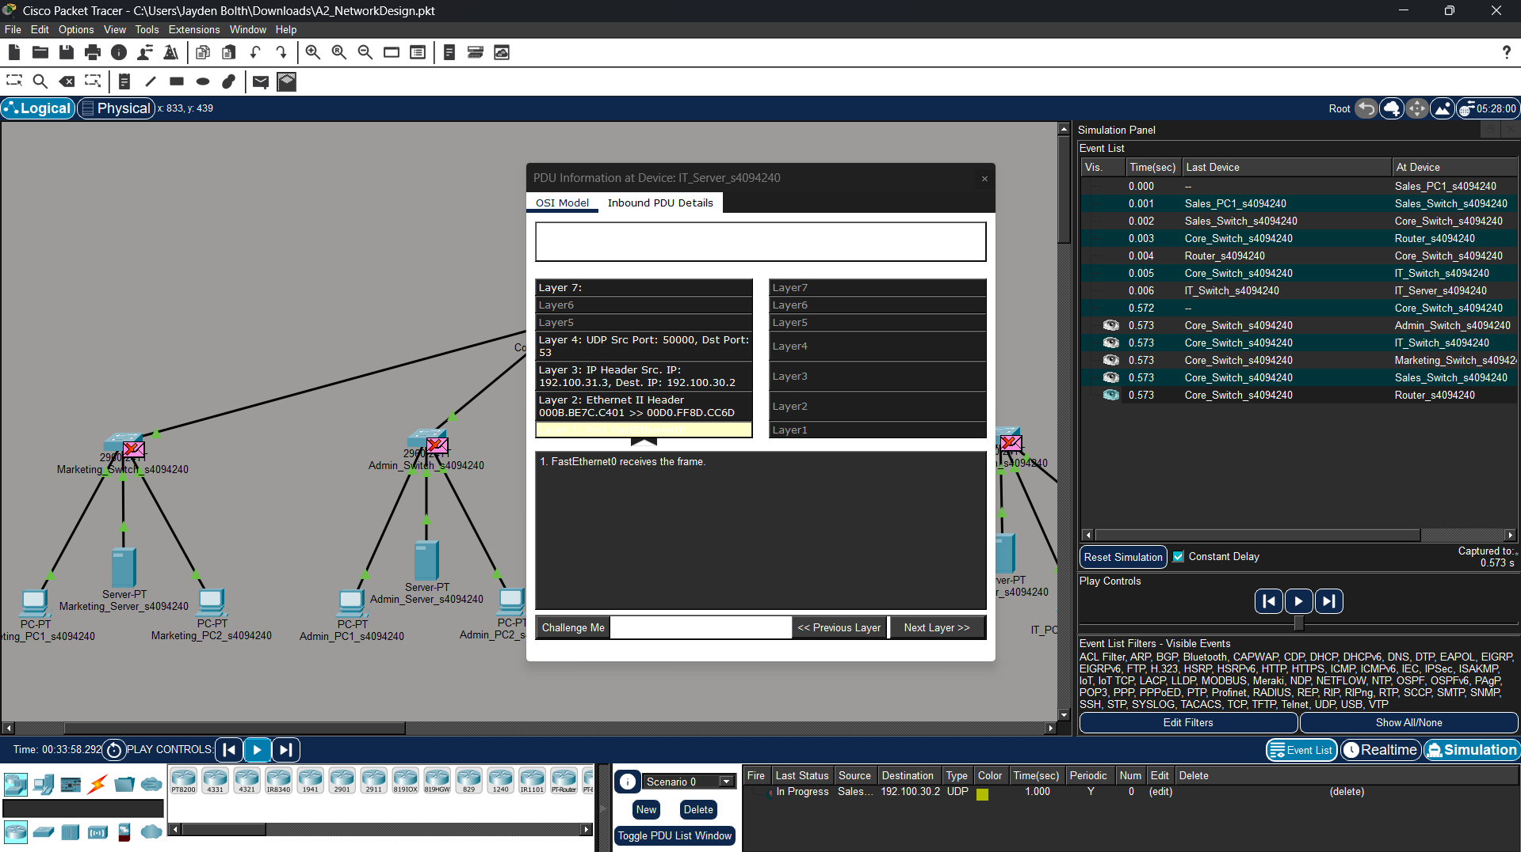
Figure 4[left most image] : Sales Server HTTP Service Configuration / Figure 5[left image]: Sales Department Web Application (accessed from IT_PC1 via http://192.100.31.2) / Figure 6[middle image]: IT Server UDP Service Configuration / Figure 7[right images]: UDP Simulation Verification in Simulation Mode

3. DNS Query Demonstrations and Observing the OSI Layers
The IT server was configured with a DNS A Record [Figure 8] mapping www.sales.com to Sales server IP address, 192.100.31.2. A Marketing client successfully resolved the domain and accessed the Sales web application, confirming DNS functionality and inter-VLAN connectivity [Figure 9].
The DNS packet was inspected in Simulation Mode [Figure 10] to show its OSI-layer flow. The capture [Figure 11]] shows DNS at Layer 7, UDP port 53 at Layer 4, source/destination IPs at Layer 3, and Ethernet MAC addressing at Layer 2
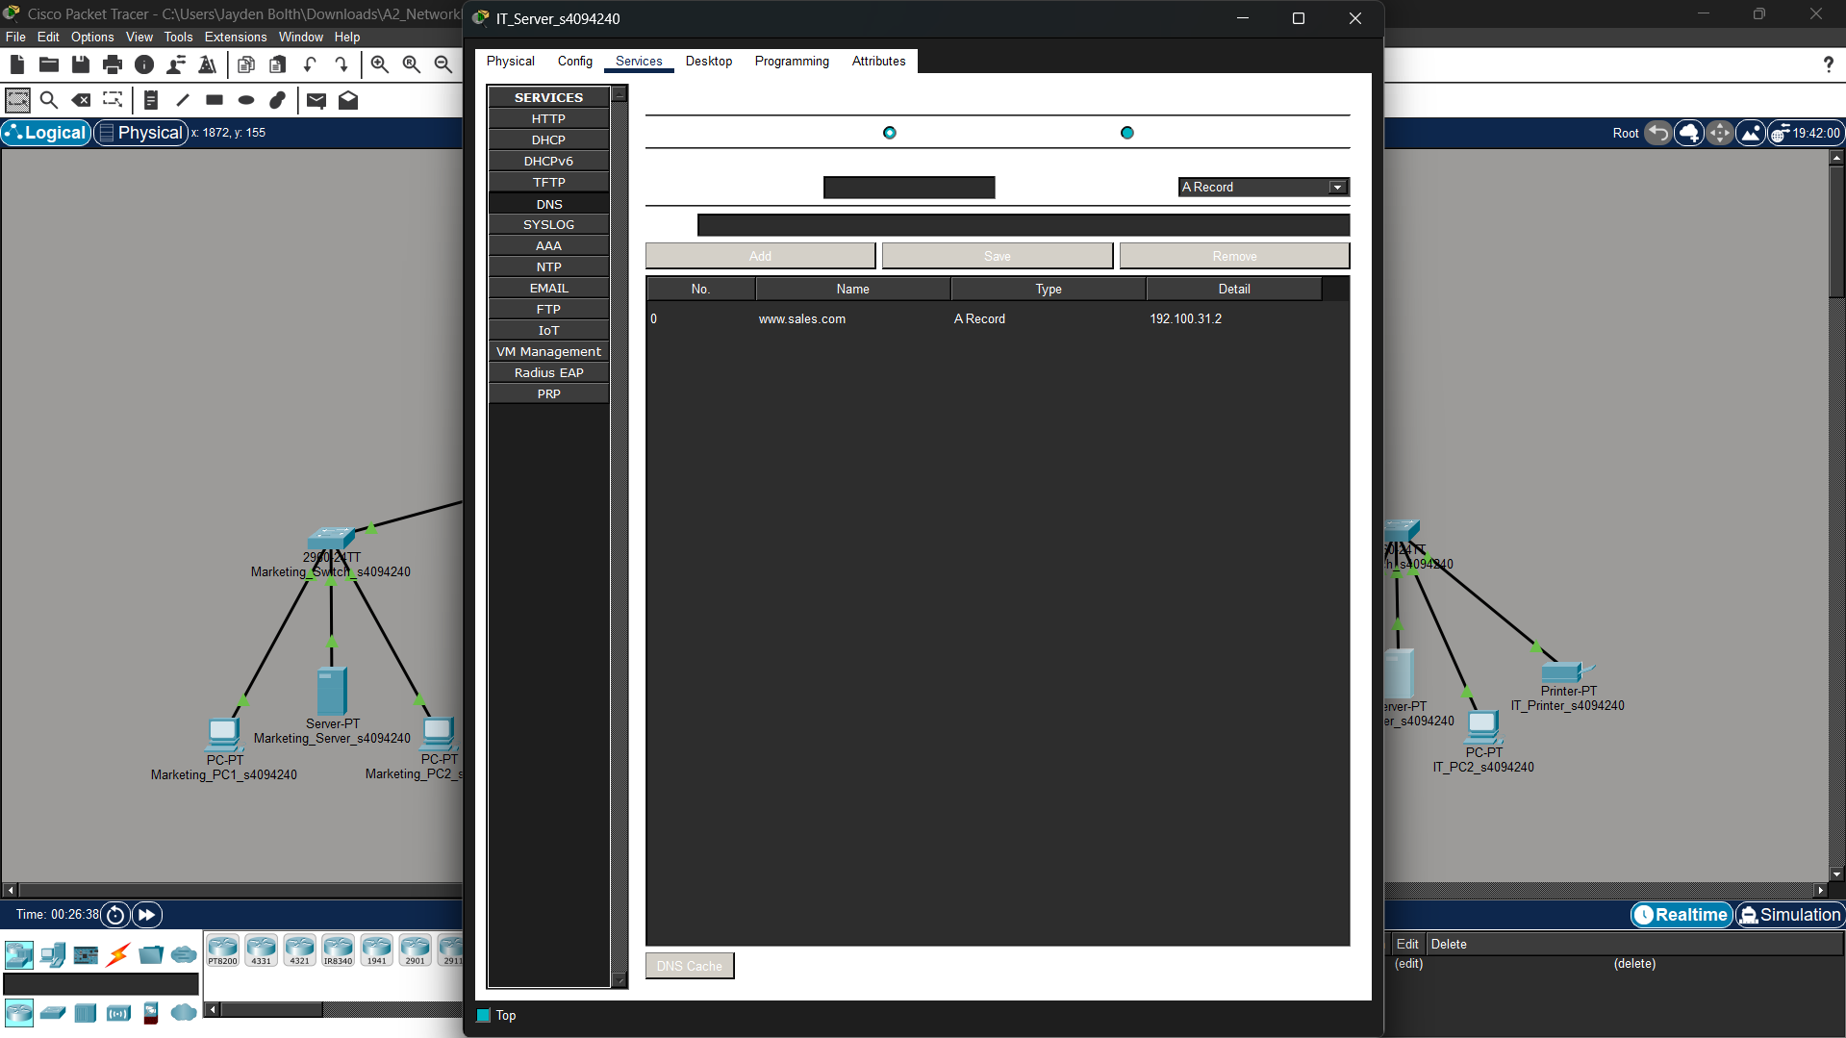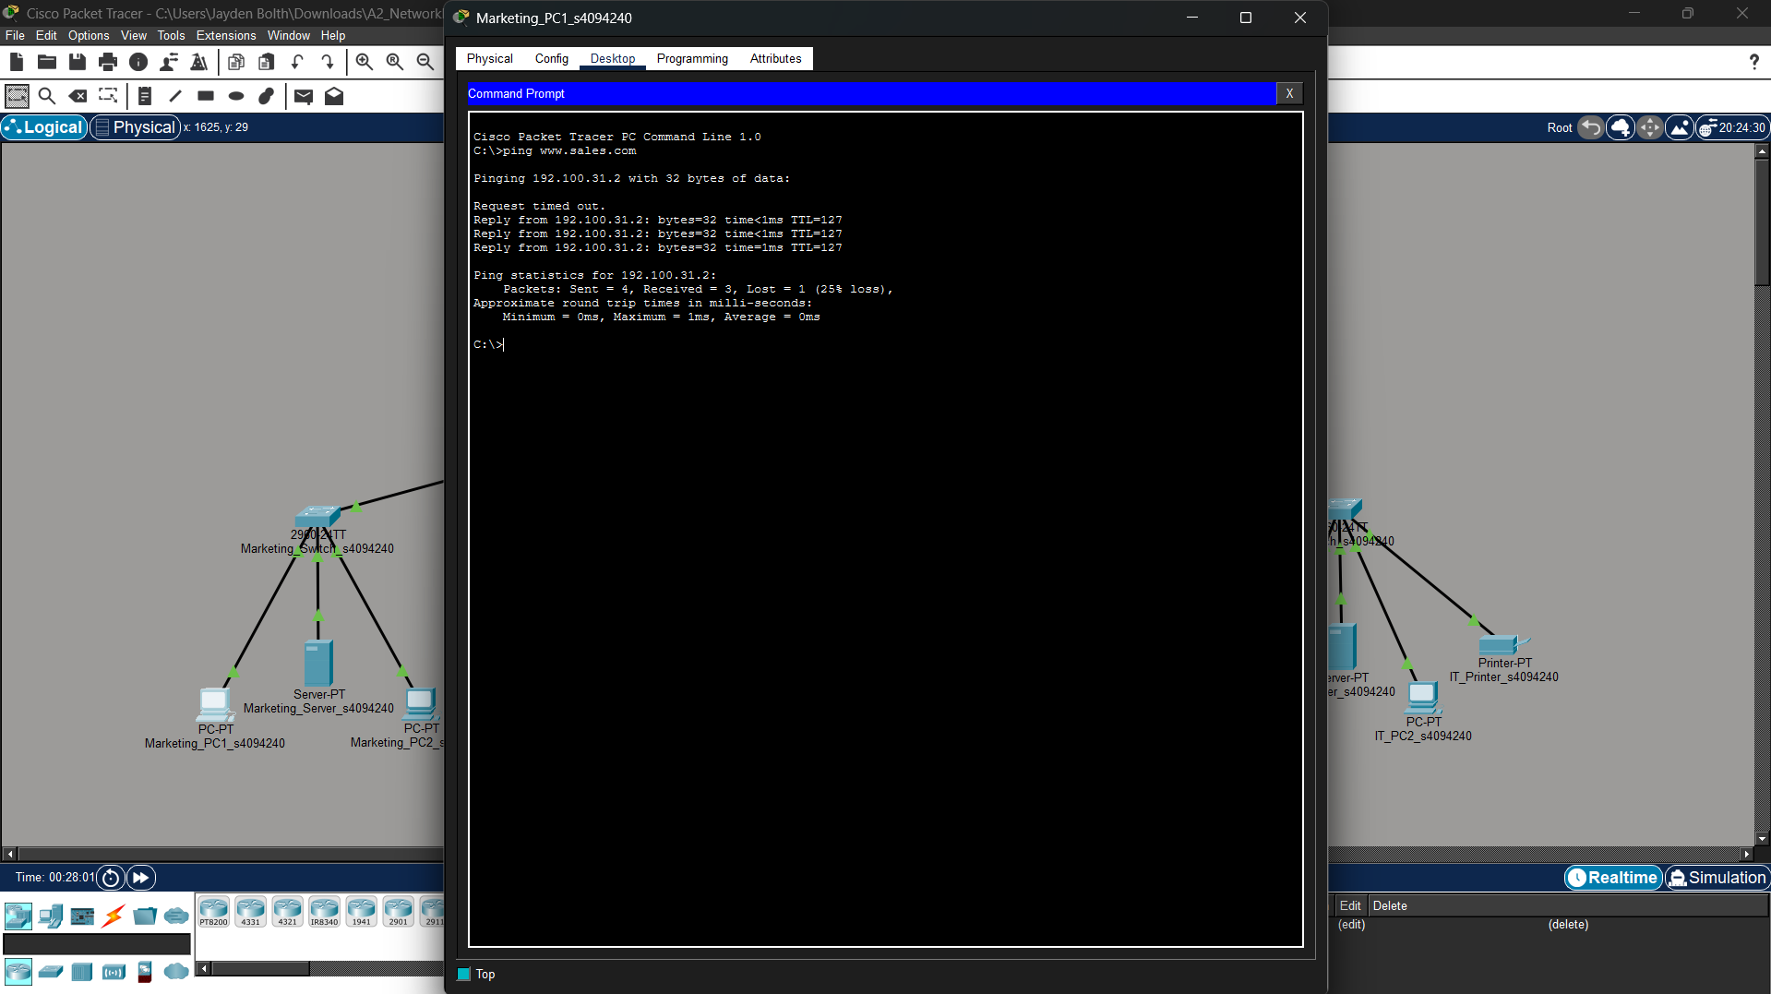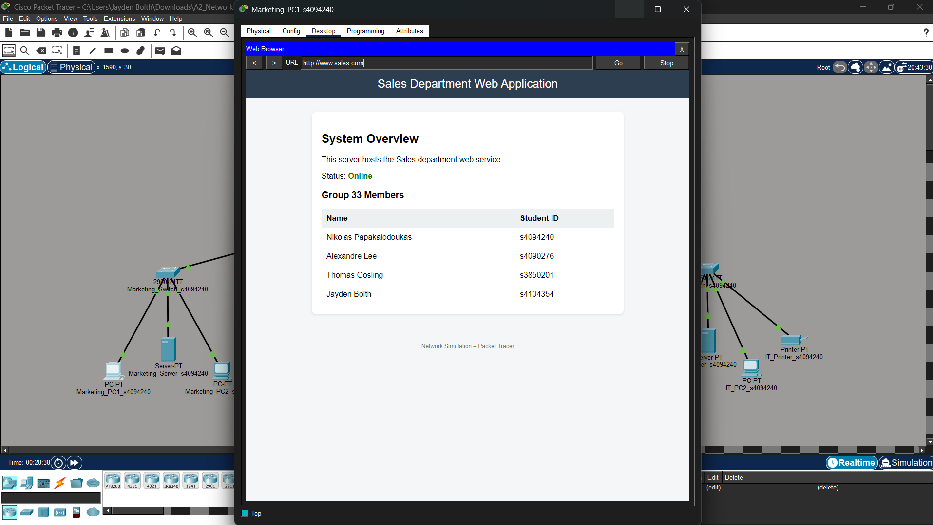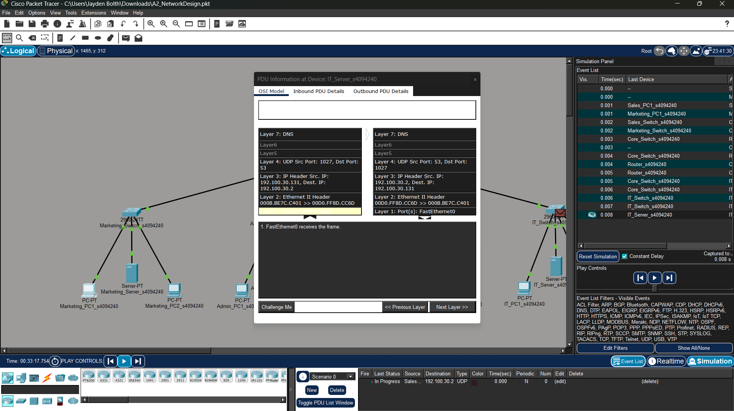
Figure 8[left most image]: IT Server DNS Configuration / Figure 9[left image]: Client DNS Query from Marketing PC / Figure 10[middle image]: DNS Connection Confirmation / Figure 11[right images]: DNS Packet OSI Layer Analysis in Simulation Mode

4. Network Design Choices Explanation
The network topology was designed using a hierarchical structure with a central core switch, connected to the switches for each department. This approach keeps the network organised by segmenting the departments, and makes it easier to manage and troubleshoot by limiting backbone connections to the router to one switch (central core). Each department was separated into its own VLAN to reduce unnecessary broadcast traffic and improve security by routing interdepartmental communication through the router. VLSM subnetting was utilised for efficient IP allocation according to departmental requirements, which reduced address wastage while supporting future scalability.
A router-on-a-stick configuration was used to enable inter-VLAN communication while avoiding the need for multiple physical router interfaces. Trunk links were configured between the core switch, router, and departmental switches so that traffic from multiple VLANs could travel across a single connection efficiently.
Servers were placed within their relevant departments to reflect realistic business usage. The Sales server hosted the web application, while the IT server provided DNS and simulated UDP-based services. Static IP addressing was employed so that key devices such as servers, printers, and networking equipment always remain accessible at known addresses.
The overall design improves scalability as the modular nature of the network allows for additional departments, VLANs, or devices without overhauling the entire network. The topology provides a network that is simple, organised, secure, and allows for efficient communications.

Task B

B.1: Frame Check Sequence (FCS) Error Detection

Frame Check Sequence Explanation
The frame check sequence is a trailer field in a frame that is populated by an algorithm, in this case CRC, and the field value is used to validate the data integrity of the frame. The CRC algorithm takes the numeric binary value of the entire frame and divides it by a fixed binary divisor (Generator), determined by the network standard being used, appending the remainder (the FCS value) to the trailer of the frame in the specific FCS field. The fixed binary divisor has a most significant bit of 1 (Wikipedia, 2026a).
Receiver Error Checking Diagram | Steps to calculate FCS value with CRC:
Sender’s Steps:
(1) Append k - 1 zeroes to the data, where k is the length of the generator's binary value. This will be referred to as the padded data.

(2) Take the first k bits of the padded data (the sliding window) and perform polynomial division with the generator. If the most significant bit of the result is not 1, drop the leading zeroes and append the next n bits from the padded data. Repeat until there are no more bits to append; the remainder is the FCS value.

(3) Replace the trailing zeroes in the padded data with the k - 1 least significant bits of the remainder to produce the final frame with the FCS value added to the trailer.

Receiver’s Steps:
(1) Perform sliding window polynomial division on the frame data using the same generator which should be used ubiquitously by all network nodes. If the remainder from the polynomial division is zero then the FCS value is valid and the frame can be accepted. If the remainder is non-zero, the frame is silently discarded.

B.2: TCP/IP Layer Association with FCS
The Frame Check Sequence (FCS) is a trailer field in frames of the Network Access Layer of the TCP/IP model, specifically in the MAC (Media Access Control) sublayer. The NIC hardware handles CRC computation and FCS validation on-the-fly as frames are transmitted and received; no higher-layer software is involved in the per-hop integrity check (GeeksforGeeks, 2026).
Referring to the B.1 diagram, integrity is ensured as follows:
- FCS integrity is checked by every intermediate Network Access Layer node (switch, router interface) that receives the frame, not just at the final destination.
- The CRC algorithm is designed so that when the receiver divides the entire incoming bit-string (data + FCS) by the generator polynomial, a zero remainder signals an intact frame; the 'Yes (No errors)' branch in the B.1 diagram, leading to the frame being accepted and passed up the stack.
- If the comparison yields a non-zero remainder (the 'No (Corruption detected)' branch), the frame is silently dropped because the network access layer adheres to the end-to-end principle and a best effort quality of service policy (Wikipedia, 2026b). Wired connections are dropped silently while wireless connections will locally retransmit within Layer 2 if an acknowledgement isn't received. Recovery is then delegated to the relevant transport-layer protocol: if TCP, the receiving host's TCP stack will notice a gap in sequence numbers and trigger retransmission; if UDP, recovery is delegated to the application.

B.3: Transport Layer Protocol Trade-off
When transmitting data there is an inherent tradeoff between reliability and latency. For a connection to be reliable the sender must ensure the data is received uncorrupted. However, confirming this requires a response from the receiver, introducing latency that may increase depending on the size of the data.
Consider the use case of a video conference livestream. If TCP was used, waiting for the receiver to verify that each packet is received uncorrupted would make continuously streaming video slow and conversation between participants impossible due to unbearable latency. This is why UDP is the standard for live streaming; it drops the handshake, discards out of sequence packets and never retransmits, leaving the application to fill in the gaps. The absence of a handshake and sequence buffering significantly reduces latency but frames are discarded and lost more frequently. This tradeoff is necessary for the user experience in livestreaming, especially for two-way communication.
Conversely, the use of TCP for downloading a video would be more appropriate to make sure that all downloaded packets are captured and sequenced to form the complete file. UDP would not be appropriate for this type of download because the received data is not guaranteed to be complete and packets that are received out of sequence would be dropped and may not be retransmitted (Gough, 2025).

Group Member Contributions
Group Member | Student ID | Contribution
Nikolas Papakalodoukas | s4094240
Alexandre Lee | s4090276
Thomas Gosling | s3850201
Jayden Bolth | s4104354

References
[1] GeeksforGeeks (2026), "What Is the Difference Between CRC and FCS?”, Accessed: 15 May 2026. https://www.geeksforgeeks.org/computer-networks/what-is-the-difference-between-crc-and-fcs/
[2] Gough H (11, 12, 2025), "TCP vs. UDP: Key differences and which one is better", Norton, Accessed 16 May 2026. https://us.norton.com/blog/wifi/udp-vs-tcp
[3] RIPE NCC 2026a, RIPE Document 504: Address Space Managed by the RIPE NCC, RIPE NCC, Accessed 8 May 2026. https://www.ripe.net/publications/docs/ripe-504/
[4] RIPE NCC 2026b, RIPE Document 484: IPv4 Address Allocation and Assignment Policies, diff from RIPE-622, RIPE NCC, Accessed 8 May 2026. https://www.ripe.net/publications/docs/ripe-484/diff/ripe-622/
[5] Wikipedia 2026a, “Cyclic redundancy check”, Wikipedia, Accessed 16 May 2026. https://en.wikipedia.org/wiki/Cyclic_redundancy_check
[6] Wikipedia 2026b, “End-to-end principle”, Wikipedia, Accessed 16 May 2026. https://en.wikipedia.org/wiki/End-to-end_principle

